[Home](https://www.raywenderlich.com/)  [Game Tech Tutorials](https://www.raywenderlich.com/gametech)

**How to Make a Game Like Jetpack Joyride in Unity 2D – Part 1**

Learn how to create a game like Jetpack Joyride in Unity 2D in this three part tutorial series.



**By Mark Placzek**Jun 22 2018 · Article (35 mins) · Intermediate

Download Materials

**4.9/5**[12 Ratings · 1 Review](https://www.raywenderlich.com/5458-how-to-make-a-game-like-jetpack-joyride-in-unity-2d-part-1#ratings-count-hook)

**Version**

* C# 3.5, Unity 2017.x, Unity



[](https://srv.carbonads.net/ads/click/x/GTND42JNCKSDC2QECVSLYKQNCYBDT23YC6BD4Z3JCYSDVK3ICWADT27KFT7IE2QUCW7DLKJWCAADV5QMCKSDTKQKC6SDKK7NCYYDEK3EHJNCLSIZ?segment=placement:wwwraywenderlichcom;)[Students and Teachers, save up to 60% on Adobe Creative Cloud.](https://srv.carbonads.net/ads/click/x/GTND42JNCKSDC2QECVSLYKQNCYBDT23YC6BD4Z3JCYSDVK3ICWADT27KFT7IE2QUCW7DLKJWCAADV5QMCKSDTKQKC6SDKK7NCYYDEK3EHJNCLSIZ?segment=placement:wwwraywenderlichcom;)[**ADS VIA CARBON**](http://carbonads.net/?utm_source=wwwraywenderlichcom&utm_medium=ad_via_link&utm_campaign=in_unit&utm_term=carbon)



With the release of Unity 2017.3, much has been refined or completely changed since Kirill Muzykov’s superb Jetpack Joyride tutorial. Now is definitely the perfect time to revisit this tutorial using Unity’s beautifully matured 2D feature set and their revamped UI system. Let’s get started!

[*Jetpack Joyride*](https://en.wikipedia.org/wiki/Jetpack_Joyride) was released by Halfbrick Studios in 2011. It’s a very easy game to understand. Steal a jetpack, and fly away with it. Collect the low hanging coins and avoid the lasers!

In essence, it’s a fun twist on an endless runner that works well with touch screens: Touch the screen to fly up; release the screen to drop back down. Avoid the obstacles to stay alive as long as you can. Notably, my kids know the game well and were super excited that I was writing an update for this tutorial:

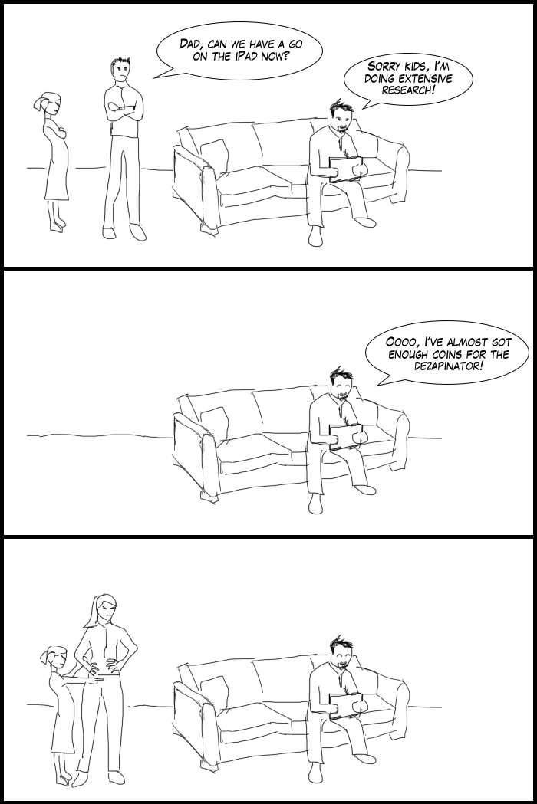

In this game, you will be steering a mouse through a very long house, collecting coins and avoiding lasers in a similar fashion. Granted, not everyone hangs coins from their walls, but I’m guessing a few of you have one or two high-wattage lasers hanging about!

This is the first part of a three part series. In this tutorial, you’ll learn how to:

* Work with physics in Unity.
* Use sorting layers to organize your sprites.
* Use colliders to define your world limits. Your mouse will be pleased to not be blasted into orbit with a long click!

[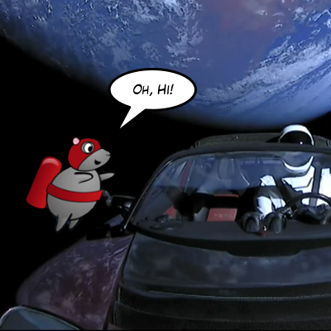](https://koenig-media.raywenderlich.com/uploads/2018/03/mouseRoadster_mplaczek.png)

Thank you to Space X for their wonderful public domain images.

In [Part 2](https://www.raywenderlich.com/187982/jetpack-joyride-in-unity-part-2), you’re going to move the mouse forward through randomly generated rooms simulating an endless level. You’ll also add a fun animation to make the mouse run when it is grounded.

In [Part 3](https://www.raywenderlich.com/187982/jetpack-joyride-in-unity-part-3), you will add lasers, coins, sound effects, music and even parallax scrolling. By the end of the series, you will have a fully functional game — albeit with a lower mice population, for sure.

**Note**: Interested in making this game in another framework? We have some deliciously old-school tutorials on how to create this game using Cocos2D 2.x and Corona. You can kick it like it’s 2013 and find those tutorials here: [Cocos2D 2.x edition](https://www.raywenderlich.com/28713/how-to-make-a-game-like-jetpack-joyride-using-latest-levelhelper-spritehelper-cocos2d-edition-part-1) and [Corona edition](https://www.raywenderlich.com/9050/how-to-make-a-game-like-jetpack-joyride-using-levelhelper-spritehelper-and-corona-sdk-part-1). Ahhh, memories…

**Getting Started**

To get started, you’ll need some art, sound effects and music for the game. Download the materials using the link at the top or bottom of this tutorial. You will also need [Unity 2017.3](https://unity3d.com/get-unity/download) or newer installed on your machine.

**Note**: The assets bundled with this project were created by the following very talented people:

* Game art created by Vicki Wenderlich for the original How to Make a Game Like Jetpack Joyride using LevelHelper, SpriteHelper tutorials.
* Sounds from freesound.org website:
  + Soft wood kick by jorickhoofd
  + Retro Coin Collect by DrMinky
  + zoup.wav by themfish
  + Rocket Flight Loop by qubodup
  + Music track called ‘Whiskey on the Mississippi’ created by Kevin MacLeod (incompetech.com).

**Also Note**: This tutorial requires you to have at least some basic experience with Unity. You’ll need to know how to work with the Unity interface, add game assets, add components to Game Objects and perform other common Unity tasks.

If you are new to Unity, check out our [Intro to Unity](https://www.raywenderlich.com/147687/introduction-unity-getting-started-part-12) tutorial to get you started.

**Creating and Configuring the Project**

Open Unity and select **New project** from the Project window, or click the **New** button on the top right if you already have a few projects in your navigator.

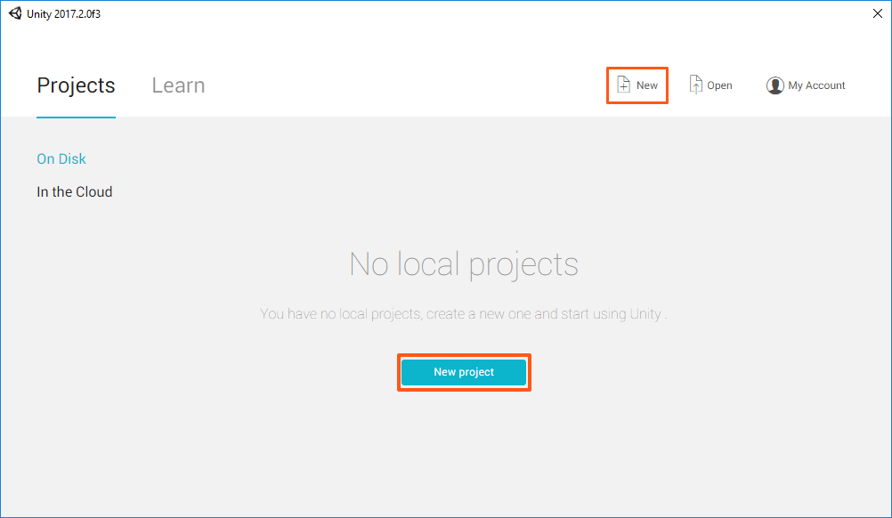

**Note**: If you’ve already created a few Unity 2D projects, feel free to use the **RocketMouse Part 1 Starter** Project in the materials. I suggest you only skip as far as Configuring the Game View to make sure your project matches the screenshots in the tutorial.

**Also Note**: You can support many different platforms and resolutions when creating games with Unity. However, for simplicity sake, in this tutorial you will work with Retina resolution images for iPhone.

Type **RocketMouse** in the **Project name** field and set the location to where you would like the project saved. The ellipsis button at the end of the field will allow you to navigate to a directory of your choosing. Once you’ve chosen a location, click **Select folder** to set the Location. Select the **2D** radio button and click **Create Project**.

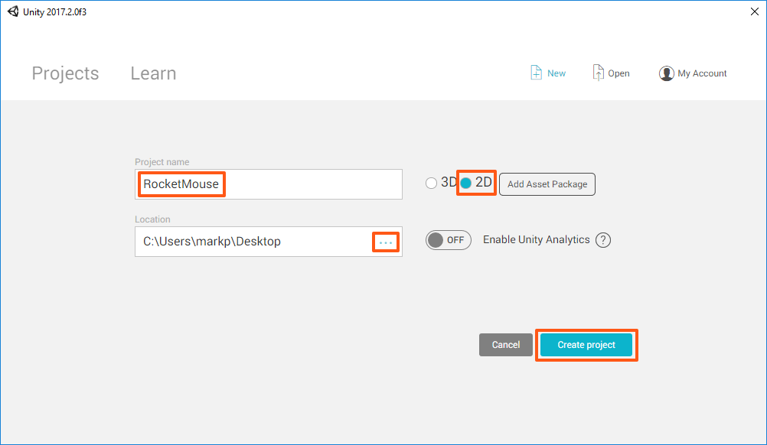

Unless you downloaded the Starter Project, create a folder named **RW** in the **Project view** using **Assets▸ ▸ Create ▸ Folder**, or use the **Create** dropdown at the top left of the Project view. You will save all subsequent folders and files you create within this directory. This will keep them separate from assets you import.

Create another new folder named **Scenes** within the **RW** directory in the Project view. Then open the Save Scene dialog by selecting **File ▸ Save Scene** or using the **⌘S** (**Ctrl+S** on Windows) shortcut. Navigate to the **Scenes folder** you just created, name the scene **RocketMouse.unity** and click **Save**.



**Configuring the Game View**

Switch to the **Game view** and set the size to a fixed resolution of **1136×640**. If you don’t have this resolution option in the list, create it and name it **iPhone Landscape**.



Select the **Main Camera** in the Hierarchy. In the **Inspector**, inside the **Camera** component, set the **Size** to **3.2**.

[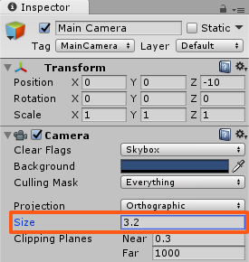](https://koenig-media.raywenderlich.com/uploads/2018/03/RM4_mplaczek.png)

**Save** the scene. There are no big changes since the project creation, but you’ve done several very important configuration steps.

**Adding the Player Character**

In this section of the tutorial you will add the player character: a cool mouse with a jetpack. Just when you thought you had seen it all!

Unpack the materials you downloaded for this tutorial and locate the two directories **Sprites** and **Audio**. You will not use the audio files until a future part of this tutorial. Just keep them handy for the time being.

**Importing Game Assets**

To add the assets, open the **RocketMouse_Resources** folder, select both the **Sprites** and **Audio** folders, and drag them onto the **Assets folder** in the **Project view**.

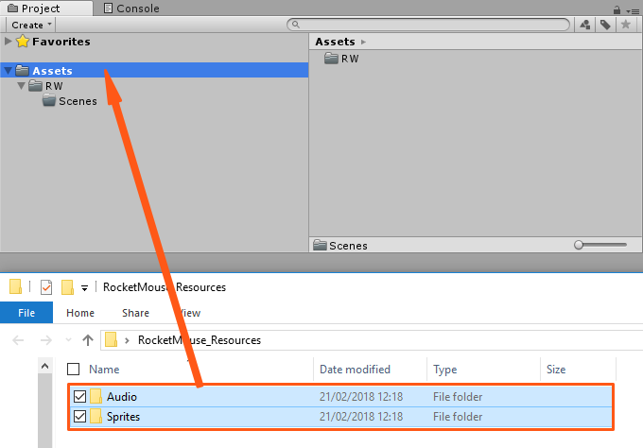

You’ve just added all required assets. At this point, it might seem that there are many strange files in there. Don’t worry, most of the images are just decorations and backgrounds. Apart from that, there is a sprite sheet for the mouse character, the laser and the coin objects.

**Adding the Player to the Scene**

Many animated game sprites are supplied in a **sprite sheet**, and our heroic mouse is no exception.

**Slicing The Mouse Sprite Sheet**

Frames of the **running**, **flying** and **dying** animation are contained within the **mouse_sprite_sheet**. Your first step is to slice it correctly.

Open the **Sprites** folder in the **Project view** and find **mouse_sprite_sheet**. Select it and set its **Sprite Mode** to **Multiple** in the **Inspector**, and then click **Apply**.

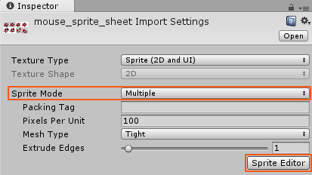

Then click the **Sprite Editor** button to open the **Sprite Editor**.

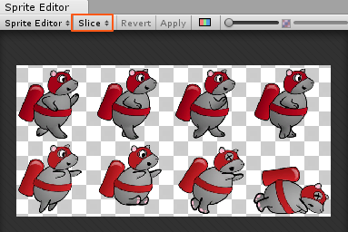

In the **Sprite Editor** click the **Slice** button near the left top corner to open the slicing options.

1. Set the **Type** field to **Grid By Cell Size**.
2. Set the **Pixel Size** to **162 x 156**.
3. Click the **Slice** button.
4. You will see a faint grid immediately appear. Don’t forget to click the **Apply** button to save changes.

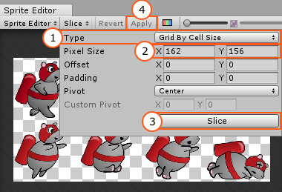

Still within the Sprite Editor, select the top left image to display its details. Click in the **Name** field and give the sprite a more appropriate name: **mouse_run_0**.

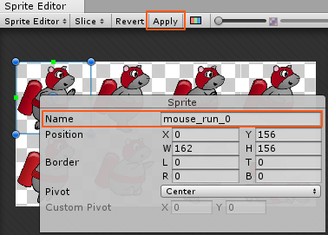

Rename the remaining sprites from top-left to bottom-right as follows:

* mouse_run_1
* mouse_run_2
* mouse_run_3
* mouse_fly
* mouse_fall
* mouse_die_0
* mouse_die_1

Click **Apply** again to save changes.

Close the **Sprite Editor**. Expand mouse_sprite_sheet in the Project view, and you will see that it was sliced into eight different sprites. Nice!

It is time to actually add something to the scene. Select the sprite named **mouse_fly** and drag it into the **Scene** view.

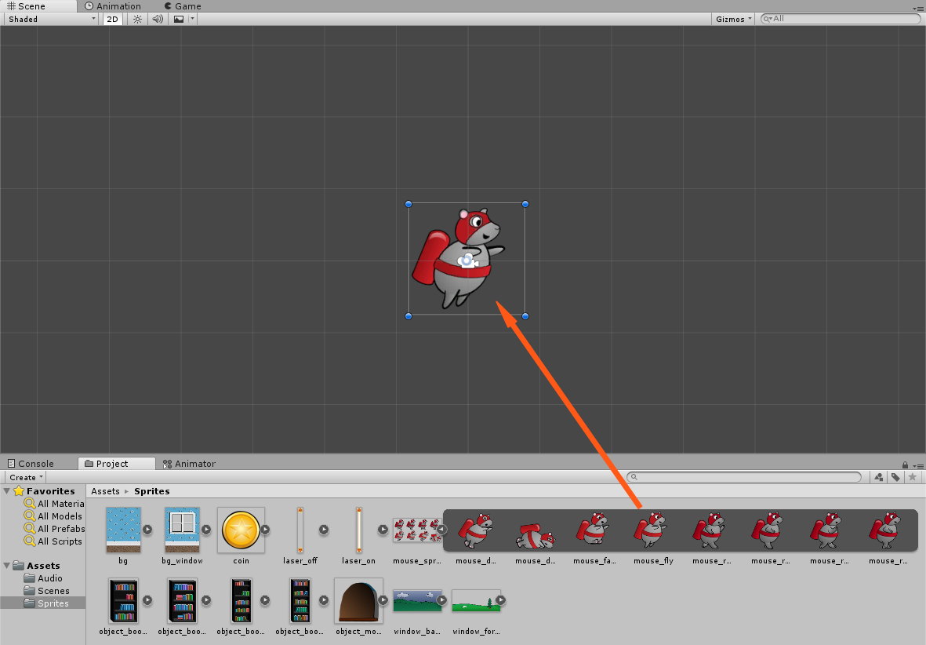

Doing this will create an object in the **Hierarchy** named mouse_fly (just as was the image used to create it).

Select **mouse_fly** in the **Hierarchy** and make the following changes in the Inspector:

1. **Change name** to **mouse**, since this will better describe the player character.
2. **Set its Position** to **(0, 0, 0)**. You will move the mouse to its final position a bit later, but right now it is better to place it right at the screen center, so that you can see it better.
3. Add a **Circle Collider 2D** component, by clicking **Add Component** in the Inspector. In the drop down menu select **Physics 2D** and then choose **Circle Collider 2D**.
4. Set the **Radius** of the Circle Collider 2D component to **0.5**.

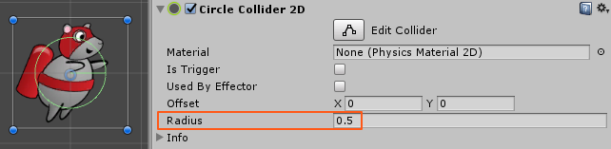

1. Add a **Rigidbody 2D** component by clicking **Add Component** and selecting **Physics 2D\Rigidbody 2D**.
2. Expand the **constraints** section within the **Rigidbody 2D** component. Enable the **Freeze Rotation Z checkbox**.

Here is an image demonstrating all the steps:

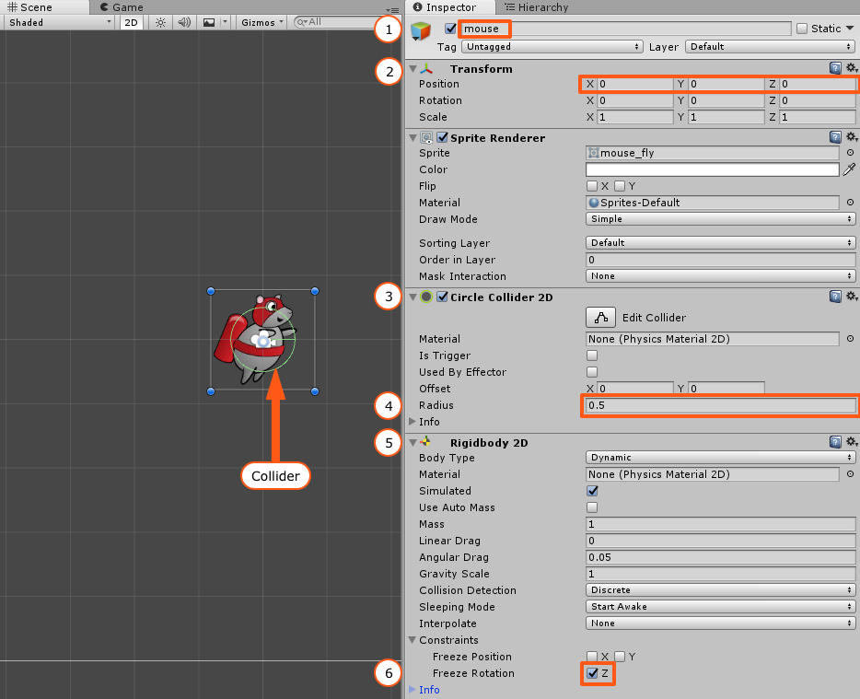

The **green circle** in the Scene view shows the collider; its size changed when you changed the Radius property of the Circle Collider 2D component.

Colliders define a shape that are used by the physics engine to determine collisions with other objects. You could have created a more pixel-perfect collider by using a **Polygon Collider 2D** component, as in the screenshot below:

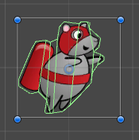

However, using complex colliders makes it harder for the physics engine to detect collisions, which in turn creates a performance hit. A good rule is to always use simple colliders whenever possible. As you will see, a circle collider works really well for this game. The only adjustment was the radius of the collider so that it matched the original mouse image.

While colliders define the shape of the object, the Rigidbody is what puts your game object under the control of the physics engine. Without a Rigidbody component, the GameObject is not affected by gravity. Thus, you cannot apply things such as force and torque to the GameObject.

In fact, you wouldn’t even detect collisions between two GameObjects, even if both had Collider components. One of the objects must have a Rigidbody component.

However, while you want the mouse to be affected by gravity and collide with other objects, you don’t want its rotation to be changed. Fortunately, this is easy to solve by enabling the **Freeze Rotation** property of the **Rigidbody 2D** component.

Run the scene and watch as the mouse falls down, affected by the gravity force.



But wait! Why did the mouse fall down at all? You didn’t add any gravity to the Rigidbody… or did you? In fact, when you added the Rigidbody 2D component, it was given a default Gravity Scale of 1. This tells the system to make the character fall using the default gravity of the physics engine.

**Creating a Script to Control the Jetpack**

You won’t let that mouse fall down into the abyss. Not on your watch!

You need to add a script that will enable the jetpack and apply force to the mouse object to move it up and keep it from falling.

To add a script to the mouse object:

1. In the Project browser, **create a new folder** within the **RW directory** called **Scripts**, just as you created the Scenes folder before. Make sure that this folder is selected, since Unity will add a new script to the currently selected folder.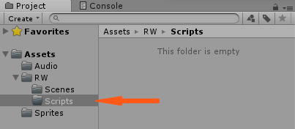
2. Select **Create ▸ C# Script** in the top menu and name the script **MouseController**.
3. Drag the **MouseController** script over **mouse** in the Hierarchy to add it to the mouse GameObject. This will add a Script component and set its Script property to MouseController script.



**Note**: Make sure you correctly name the script when you first create it, as opposed to creating a NewBehaviourScript and then renaming it. Otherwise you will get the following error when trying to add this script to a GameObject:  
Can't add script behaviour MouseController. The script's file name does not match the name of the class defined in the script!  
This happens because Unity creates the following class inside the script, and renaming the script doesn’t change the class name inside:  
public class NewBehaviourScript

It’s time to write some code. Open the **MouseController** script by double-clicking it either in the Project view or in the Inspector. This will open **MouseController.cs** in the editor of your choice.

Add the following jetpackForce variable just inside the class definition:

public float jetpackForce = 75.0f;

This will be the force applied to the mouse when the jetpack is on.

**Note**: It’s a good idea to make the variable public and set a default value. This way you can adjust the jetpack force in the Inspector, but will have a default value in case you forget or don’t want to adjust it.



Just below jetpackForce, add the following variable:

private Rigidbody2D playerRigidbody;

Next add the following code to the automatically generated Start method:

playerRigidbody = GetComponent<Rigidbody2D>();

When the game starts, you retain a reference to the player’s Rigidbody. You will need to access this component very frequently in this script, and you don’t want to create a performance hit every time you need to locate it.

Next, add the following method inside the class:

void FixedUpdate()

{

bool jetpackActive = Input.GetButton("Fire1");

if (jetpackActive)

{

playerRigidbody.AddForce(new Vector2(0, jetpackForce));

}

}

FixedUpdate() is called by Unity at a fixed time interval. All physics-related code is written in this method.

**Note**: The difference between Update and the FixedUpdate is that FixedUpdate is called at a fixed rate, while Update is simply called for every rendered frame. Since frame rate can vary, the time between subsequent Update method calls can also vary and physics engines do not work well with variable time steps. This is why FixedUpdate exists and should be used to write the code related to the physics simulation (e.g. applying force, setting velocity and so on).

In FixedUpdate, you check if the Fire1 button is currently pressed. In Unity, **Fire1** by default is defined as a left mouse button click, the left Control key on a keyboard, or a simple screen tap in the case of an iOS app. For this game, you want the jetpack to engage when the user touches the screen. Therefore, if Fire1 is currently pressed, the code will add a force to the mouse.

AddForce simply applies the force to the rigidbody. It takes a Vector2 that defines the direction and the magnitude of the force to apply. You will move your hero mouse forward later, so right now you only apply the force to move the mouse up with the magnitude of jetpackForce.

Run the scene and hold your left mouse button to enable the jetpack and make the mouse move up.



**Adjusting the Gravity**

The jetpack works, but you can see several problems straight away. First, depending on your perspective, the jetpack force is either too strong, or the gravity is too weak. It’s far too easy to send the mouse flying off the top of the screen, never to be seen again.

Rather than change the jetpack force, you can change the gravity setting of the entire project. By changing the gravity setting globally, you set a smarter default for the smaller iPhone screen. And besides, who doesn’t like the idea of controlling gravity?

To change the gravity force globally, chose **Edit ▸ Project Settings ▸ Physics 2D**. This will open the Physics 2D Settings of the project in the Inspector. Find the **Gravity** field and set its **Y** value to **-15**.

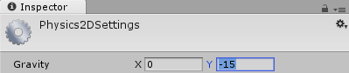

Run the scene again. It should be much easier to keep the mouse within the game screen.



Don’t worry if you’re still having difficulties keeping the mouse within the game screen. Try making your Game view bigger or adjust the jetpackForce or Gravity settings. The values recommended here work well when you run the game on the iPhone. Of course, adding a floor and a ceiling will help keep the mouse in sight, so you’ll add those next.

**Adding the Floor and the Ceiling**

Adding a floor and a ceiling is a relatively simple exercise; all you need is an object for the mouse to collide with at the top and bottom of the scene. When you created the mouse object earlier, it was created with an image so the user could visually track where the object is throughout the game. The floor and ceiling, however, can be represented by empty GameObjects, as they never move, and their location is relatively obvious to the user.

Choose **GameObject ▸ Create Empty** to create an empty object. You won’t see it on the screen. What do you expect? It’s empty!

Select the new **GameObject** in the Hierarchy and make the following changes in the Inspector:

1. Rename it to **floor**.
2. Set its **Position** to **(0, -3.3, 0)**.
3. Set its **Scale** to **(14.4, 1, 1)**.
4. Click **Add Component** and add a **Box Collider 2D** component by selecting **Physics 2D\Box Collider 2D**.

Now you should see a green collider at the bottom of the scene:

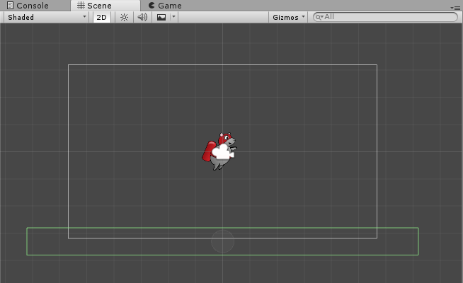

Don’t worry too much about the magic numbers in the Position and Scale properties; they will make more sense later as you add more elements to the Scene.

**Note**: You didn’t add a Rigidbody 2D component to the floor game object. This is because the floor should only limit the mouse movement, but it shouldn’t be affected by gravity, nor will you apply a force to it.

Run the scene. Now the mouse falls on the floor and stays there.



However if you activate the jetpack, the mouse still leaves the room since there is no ceiling.

I’m sure you can add a ceiling yourself. Set its **Position** to **(0, 3.7, 0)**, and don’t forget to rename it **ceiling**. If you need a hint, check the spoiler below.

Reveal

Now there is both a floor and a ceiling present in the scene. Run the game, and try as you might, the mouse will never fly off the top or fall off the bottom of the scene.



**Using a Particle System to Create Jetpack Flames**

Now that you’ve got the mouse moving at the user’s every will, it’s time to add some flair — or is that *flare*? In this section, you’ll make the jetpack shoot flames when the mouse goes up. Why flames? Because everything’s better with flames!

There are many different ways you can show flames coming out of the jetpack, but my personal favorite is using a **Particle System**. Particle systems are used to create a lot of small particles and simulate effects like fire, explosions, fog, all based on how you configure the system.

**Creating a Particle System**

To add a Particle System to the scene, choose **GameObject ▸ Effects ▸ Particle System**. You’ll notice a change to the scene immediately: the Particle System will show its default behavior in the Scene when the object is selected.

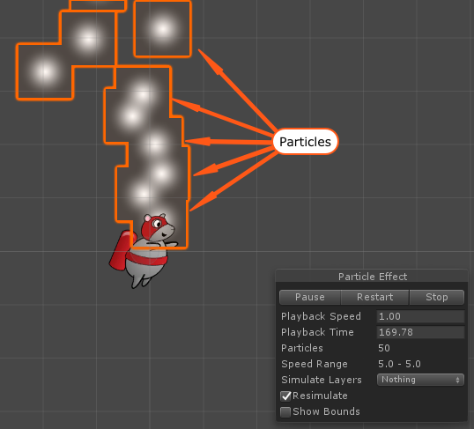

This is a good start, but right away you should notice some problems. First, the particle system always stays in the middle of the screen, regardless of where the rocket mouse flies. To make the particles always emit from the jetpack, you’ll need to add the Particle System as a child of the mouse. In the **Hierarchy**, drag the **Particle System** over the **mouse** to add it as a child. It should look like the following screenshot:

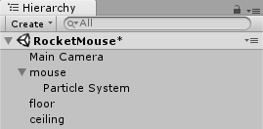

Now that the Particle System moves correctly, configure it to resemble flames by selecting the **Particle System** in the Hierarchy and changing the following in the **Inspector**:

1. Rename the Particle System to **jetpackFlames**.
2. Set its **Position** to **(-0.62, -0.33, 0)** to move it to the jetpack nozzle.
3. Set its **Rotation** to **(65, 270, 270)** to set the direction at which the particles will be emitted.
4. Still in the **Inspector**, find the Particle System component and set following properties:

* Set **Start Lifetime** to **0.5**
* Set **Start Size** to **0.3**
* Click on **Start Color** and set **Red** to **255**, **Green** to **135**, **Blue** to **40** and leave **Alpha** at **255**. You should get a nice orange color.
* Expand the **Emission** section and set **Rate over Time** to **300**. Make sure you don’t uncheck the checkbox to the left of Emission section and disable it.
* Expand the **Shape** section. Make sure **Shape** is set to **Cone**, set **Angle** to **12** and **Radius** to **0.1**. Finally set the **Randomize Direction** to **1**.

Here is how the particle system should look:



If your jetpack flames look different, make sure you’ve set all the settings shown on this screenshot:

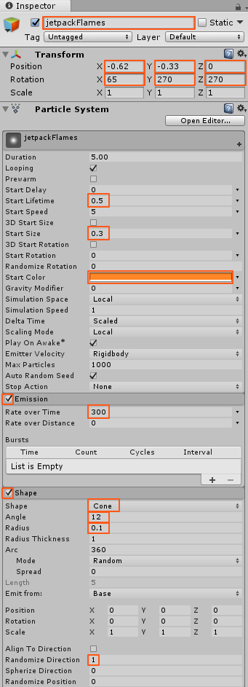

**Improving the Flames**

The flames are looking good, but you’ll notice that the flame particles stop suddenly, as if they hit an invisible wall at the end of the particle emitter. You can fix this by changing the color of the particles as they fall further from the jet pack.

Select **jetpackFlames** in the **Hierarchy** and search for a section called **Color over Lifetime** in the **Particle System** component. Enable it by checking the **white circle checkbox** to the left of the section name and click the **title** to expand the section.



**Note**: Right now the color is just plain white. This might seem strange, since you can clearly see the orange color of the flames. However, Color over Lifetime works in a bit of a different way. Instead of setting the color, this setting multiplies itself with the Start Color value.  
Since multiplying any color with white simply gives the original color, you always see the orange color. But you can change the Color over Lifetime to a gradient and set the end color to have 0 alpha. This way particles will disappear gradually.

Click the **white color** box within **Color over Lifetime** to open the Gradient Editor. It should look like this:

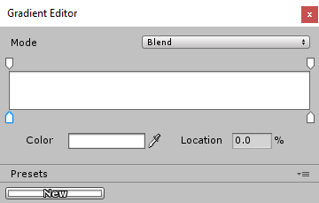

Select the **top slider on the right** and change the **Alpha** value to **0**. Then close the Gradient Editor.

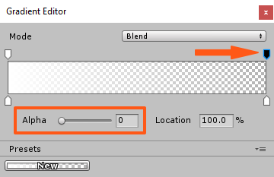

Run the scene. Now the jetpack flames look much more realistic.



**Creating a Level Section**

Remember that the mouse should glide through an endless room, avoiding lasers and collecting coins. Unless you have a huge amount of time on your hands, I highly recommend not creating your endless room by adding everything by hand!

You are going to create a few different level sections and add a script that will randomly add them ahead of the player. As you might imagine, this can’t all be done at once! You’ll start by simply adding a few background elements in this tutorial.

In Part 2, you’ll start creating additional rooms for the mouse to fly through.

This is how one level section might look like:

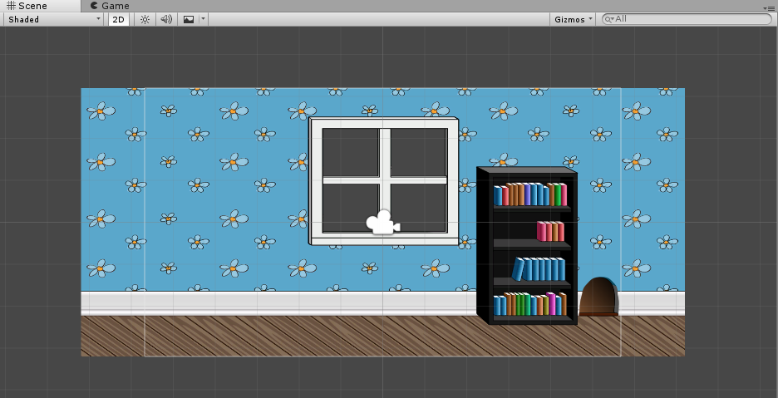

The process of creating a level section (let’s call one section a room) consists of three steps:

* Adding the background
* Adding the floor and the ceiling
* Adding decorative objects

**Adding the Room Background**

Make sure the **Scene** view and the **Project** view are visible. In the **Project** view, open the **Sprites** folder and drag the **bg_window** sprite to the scene. You don’t need to place it in a precise location; you’ll take care of that in a minute.



Select **bg_window** in the **Hierarchy** and set its **Position** to **(0, 0, 0)**.

After placing the central section of the room, you need to add a few more sections, one to the left and one to the right of the window.

This time use the **bg** sprite. Find **bg** in the **Project** view and drag it to the scene twice. First time to the left, and second time to the right of **bg_window**. Don’t try to place it precisely. Right now you only need to add it to the scene.

You should get something like this:

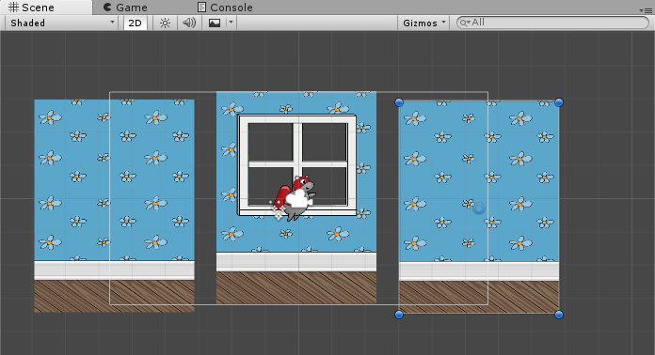

Looks like a room by Salvador Dali, doesn’t it?

**Note**: Wondering why you have to build the room around the (0, 0, 0) point? This is so you can add all rooms to an Empty game object, so you need to make sure that you know where the room center point is. It will get clearer when you start generating the level.

**Using Vertex Snapping**

You could simply position every background element on the screen based on each element’s size, but moving objects by calculating these values all the time is not very convenient.

Instead you’re going to use Unity’s **Vertex Snapping** feature, which easily allows you to position elements next to each other. Just look how easy it is:



To use vertex snapping, you simply need to hold the **V key after selecting**, but **before moving the GameObject**.

Select the room background object that you want to move. Don’t forget to release the mouse button. Then hold the **V key** and move the cursor to the corner you want to use as a pivot point.

This will be one of the left corners, for the background to the right of the window, and one of the right corners (any) for the background to the left of the window.

Note how the blue point shows which vertex will be used as pivot point.

After selecting the pivot point, hold down the **left mouse button** and start moving the object. You will notice that you can only move the object so that its pivot point matches the position of the other sprite’s corner (vertex).

If you run the game scene, you will notice your jetpack flames are behind the background. It’s possible that even your brave rocket mouse is hiding from view! In fact, any new sprites you drag into the scene may not be correctly positioned by Unity with respect to depth.

New sprites may be positioned behind or in front of any other sprite. You will be adding some decorations to your room soon but they will look pretty silly on the outside of your house! So for perfect control of sprite depth in the scene, you’ll next look at using **Sorting Layers** to control their ordering.

**Using Sorting Layers**

To make sure your background stays in the background, and that your mouse does not duck behind a bookcase mid-game, you’re going to use a feature called Sorting Layers. It will take only a moment to set everything up.

Select the **mouse** in the **Hierarchy** and find the **Sprite Renderer** component in the **Inspector**. There you will see a drop down called **Sorting Layer**, which currently has a value of **Default**, as it is shown below.

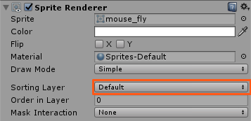

**Open the drop down** and you’ll see a list of all the sorting layers that you currently have in your project. Right now there should be only **Default**.

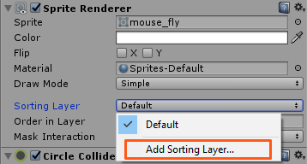

Click on the **Add Sorting Layer…** option to add more sorting layers. This will immediately open the **Tags & Layers** editor.

Add the following sorting layers by clicking the **+** button.

1. Background
2. Decorations
3. Objects
4. Player

**Note**: The order is important, since the order of sorting layers defines the order of the objects in the game.

When you’re done the Tags & Layers editor should look like this:

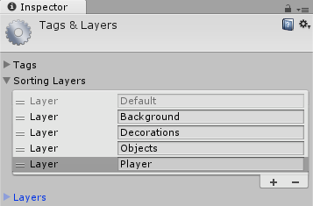

For now you’re only going to need Background and Player sorting layers. Other sorting layers will be used later.

Select **mouse** in the **Hierarchy** and set its **Sorting Layer** to **Player**.

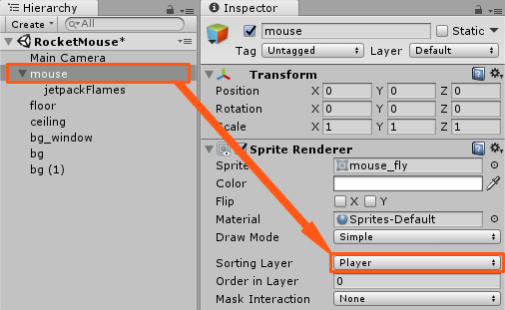

Now select the three background pieces, **bg_window, bg and bg (1)** in the **Hierarchy** and set their **Sorting Layers** to **Background**.

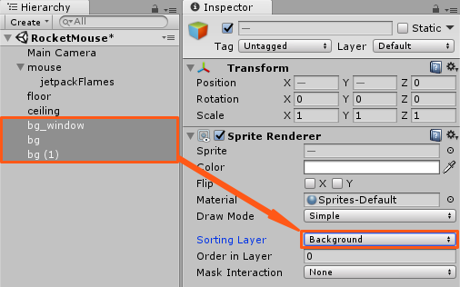

Thankfully, this new version of Unity introduces the same sorting layer parameters to particle effects. This makes the use of particle effects in 2D games far more practical. Select the **jetpackFlames** in the **Hierarchy**. In the **Inspector** find the **Renderer tab** at the bottom of **Particle System** and click to expand it. Set the **Sorting Layer** to **Player** and the **Order in Layer** to **-1**. The Order in Layer sets the order of the object within its sorting layer for even finer control.

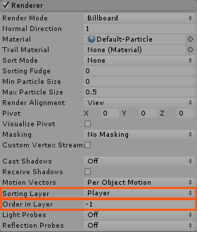

You set the jetpackFlames to -1 so that they are always emitted from under the player’s mouse sprite.

Run the game and you should see that the jetpack flames are now displayed above the background.



**Decorating the Room**

To decorate the room you can use any amount of bookcases and mouse holes from the **Sprites** folder in the **Project** browser. You can position them any way you want. Just don’t forget to set their **Sorting Layer** to **Decorations**.

Here is a decorated room example:

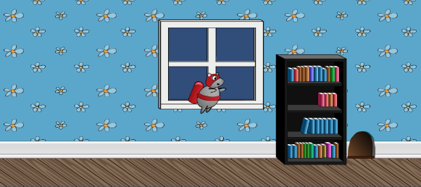

Need some decorating inspiration? In the **Project** browser find an image named **object_bookcase_short1**. Drag it to the scene just as you did with room backgrounds. Don’t try to position it somewhere in particular, just add it to the scene.

Select **object_bookcase_short1** in the **Hierarchy** and set its **Sorting Layer** to **Decorations**. Now you will be able to see it.

Set the bookcase **Position** to **(3.42, -0.54, 0)** or place it anywhere you want. Now add the **object_mousehole** sprite. Set its **Sorting Layer** to **Decorations** and **Position** to **(5.15, -1.74, 0)**.

**Note**: You don’t have to decorate things exactly I did — maybe yours is a rich city mouse and can afford two book cases!

Just don’t cover the window with book cases. You will add something ouside the window to look at later in the tutorial.

Now, this is starting to look like a real game!